LAB05 REPORT

**1. Swing components**

**1.1 AWTAccumulator**

**1.2 SwingAccumulator**

**2. Organizing Swing components with Layout Managers**

**3. Create a graphical user interface for AIMS with Swing**

**3.1. View Store Screen**

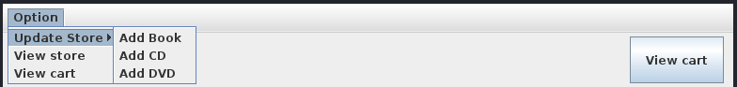

**3.2. Adding more user interaction**

**4. JavaFX API**

**Handle Erase Function**

**5 Setting up the View Cart Screen with ScreenBuilder**

**5.2 Setting up the TOP area**

**5.3 Setting up the CENTER area**

5.4 Setting up the RIGHT area

**6. Integrating JavaFX into Swing application – The JFXPanel class**

**7. View the items in cart – JavaFX’s data-driven UI**

**8. Updating buttons based on selected item in TableView – ChangeListener**

**9. Deleting a media**

**10. Filter items in cart – FilteredList**

**11. Complete the Aims GUI application**

Filter by ID

Filter By Title

* AddItemToStoreScreen

* AddDigitalVideoDiscToStoreScreen

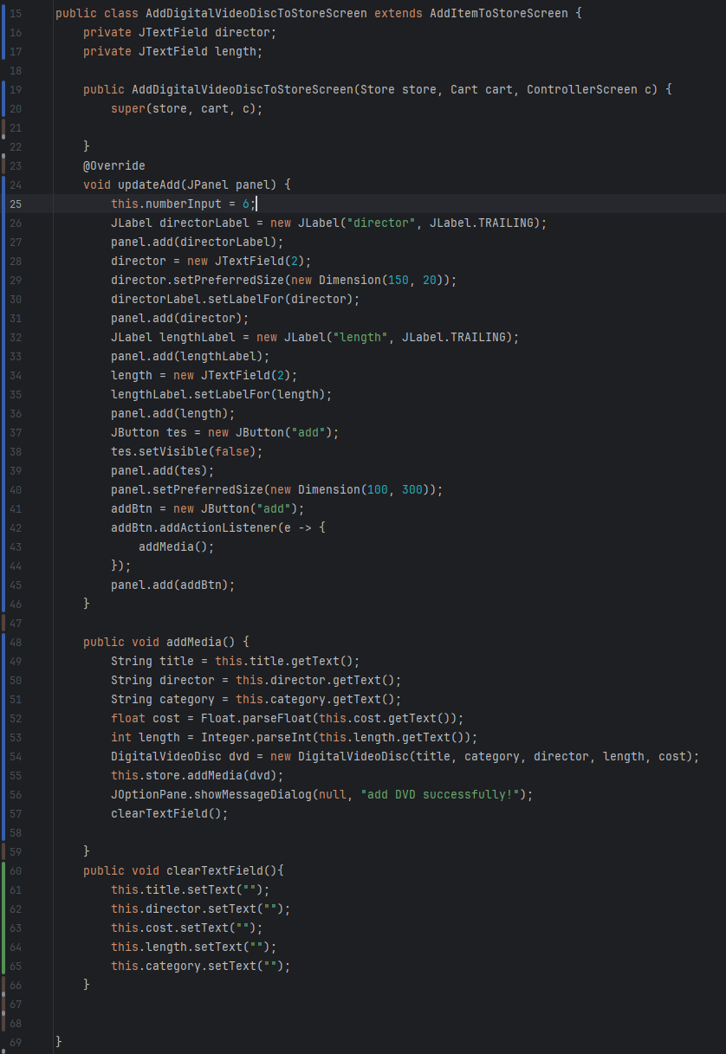

* AddCompactDiscToStoreScreen

* AddBookToStoreScreen

**12. Check all the previous source codes to catch/handle/delegate runtime exceptions**

**13. Create a class which inherits from Exception**

* **CompactDisc**

* **DVD**

* **Track**

**Updated Aim class**

* Modified equals() method of Media class

**Update Aims class diagram**

